



AU

**UTC Chubb Process Summary**

Jun 07, 2018

**Title of Document**

Title of Document

# Table of Contents

1. Table of Contents 2

2. Introduction 3

3. As -Is Business Process Overview 4

*Step 1.* Template Opportunity Creation 4

*Step 2.* Job Type selection 4

*Step 3.* Site Selection 5

*Step 4.* Invoice to Information 5

*Step 5.* Quote to info 6

*Step 6.* System Data 6

*Step 7.* Monitoring Option 7

*Step 8.* Item Selection 7

*Step 9.* Price Summary Screen- 10

*Step 10.* Recurring Price 11

*Step 11.* Legal Settings 11

*Step 12.* Approver Workflow - 11

*Step 13.* Output Forms 12

*Step 14.* Quote Negotiations and Quote Closing 13

# Introduction

UTC Chubb has engaged L&T Infotech (LTI) to provide consulting services and help select CPQ platform as to be solution across all Chubb business units. In the future state, the business units will use Microsoft CRM for sales force management and JDE for ERP. The target CPQ solution will address the needs of the business units around deal configuration, pricing and quoting, as well as integration with the respective back office systems.

There are 3 stages in the study,

*Phase 1 - Pre-workshop*

*Phase 2 – Workshop*

*Phase 3 - Post-Workshop follow-up*.

We are currently in the Phase 1 and need to understand the current Quotation process, business pain points and needs.

Based on the initial questionnaire and subsequent discussion the document has been created. As Chubb SME, please confirm the understanding and highlight if anything has not been captured which can affect the outcome of the study, especially around:

* Current state and processes followed
* Product Structure and pricing
* Business rules and workflows
* Challenges and pain-points

# As -Is Business Process Overview

## Template Opportunity Creation

Opportunities/Leads are created in MS Dynamic CRM, which triggers creation of a corresponding template for opportunity/lead in iSales. Typically, the iSales templates have a few fields pre-populated and others can then be edited/updated.

## Job Type selection

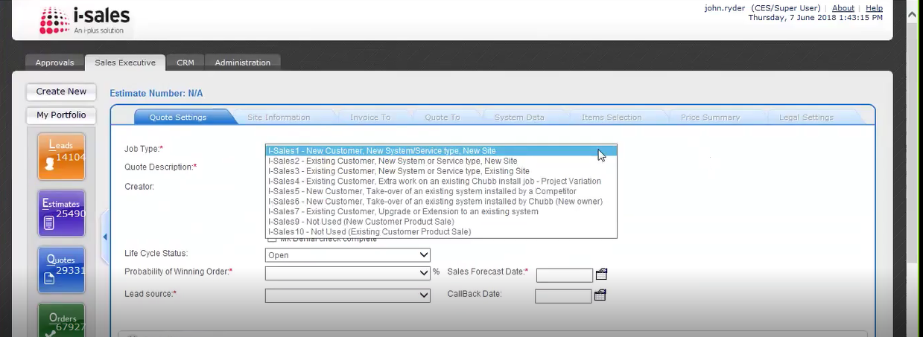

Figure 2: iSales quote Job Type Selection

Customer info flows from FieldOne (CRM) to Pronto (ERP) to iSales. All the approval workflow happens in iSales.

Job type can be selected from list in dropdown.

(*Job type 9 and 10 in Fire are product sales type of job. Product info comes from ERP.

Fire business uses Quote Standard dropdown which affects output forms and pricing because standard decides number of visits and type of testing required..)

Quote can be any one or combination of

* Installation
* Maintenance
* Monitoring

Product sales (Job type 9 and 10 in Fire) cannot be done with either Installation, Maintenance or Monitoring.

## Site Selection

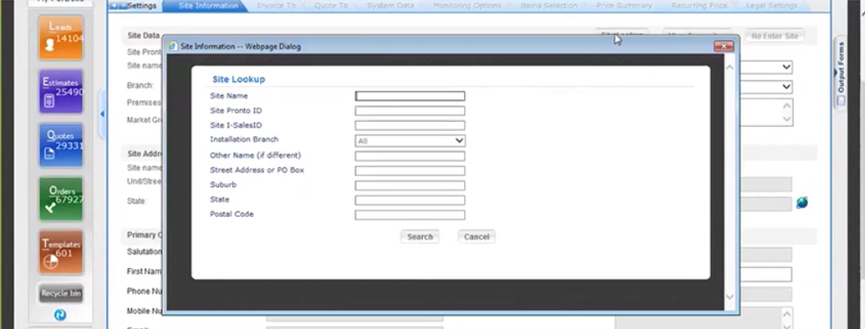

Figure 3: Site information dialog

Site info comes from ERP. User have facility to lookup the Site.

Challenge- Site selection is difficult if multiple systems are at same address.

## Invoice to Information

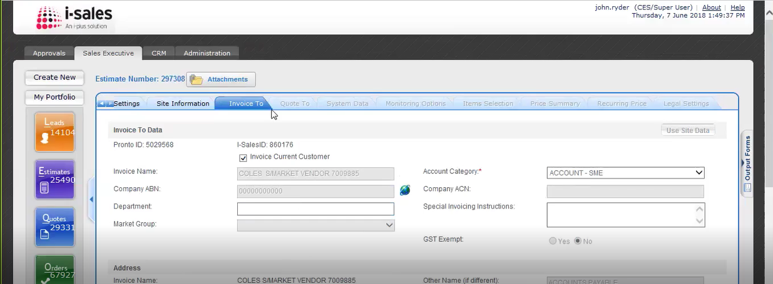

Figure 4: Invoice To dialog

Invoice to address and contact person information is to be entered here.

For existing customers info is auto populated.

## Quote to info

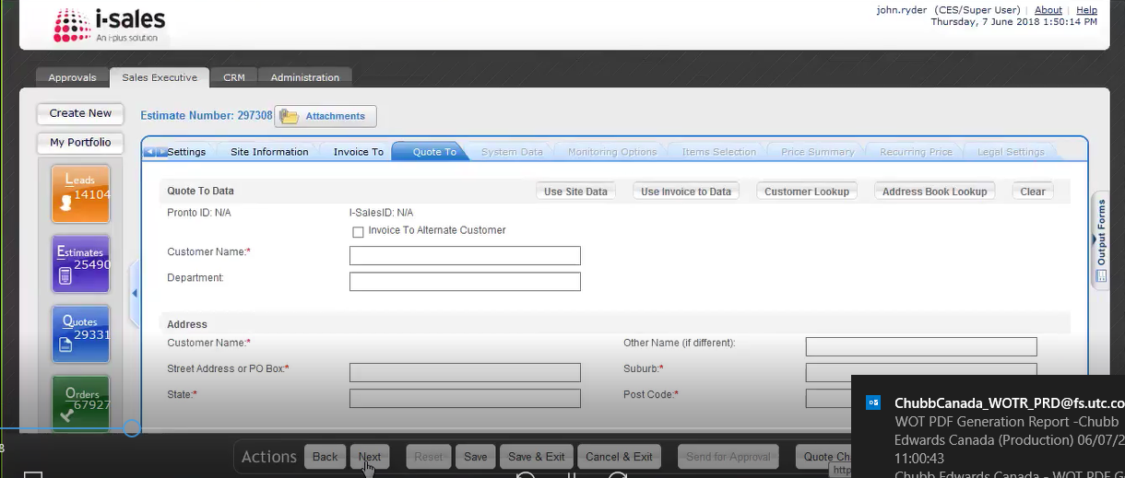

Figure 5: Quote To dialog

If quote is to be sent to address other than site address (e.g. to third party) then user can enter the details.

If it’s same as site address then user can copy the site contact information.

## System Data

Information collected regarding nature of work is entered here for reporting and analysis purpose.

(*Till this tab same info is collected for Security and Fire. Fire business collected more information for billing on this page. System type selected on this page decides approval process for Fire.)

Billing info is stored in iSales and for some items it comes from ERP.

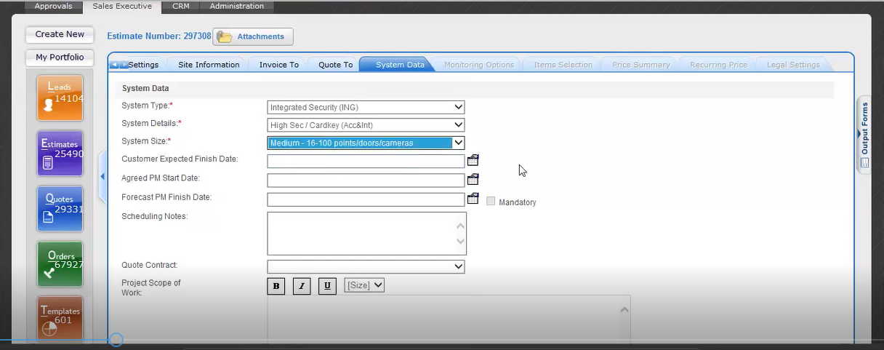

Figure 6: System Data

## Monitoring Option

This screen appears if monitoring option is selected for quote.

User can apply discount to the price and screen shows weekly price, billing cycle price and annual price.

Pricing info is stored in iSales in lookup table.

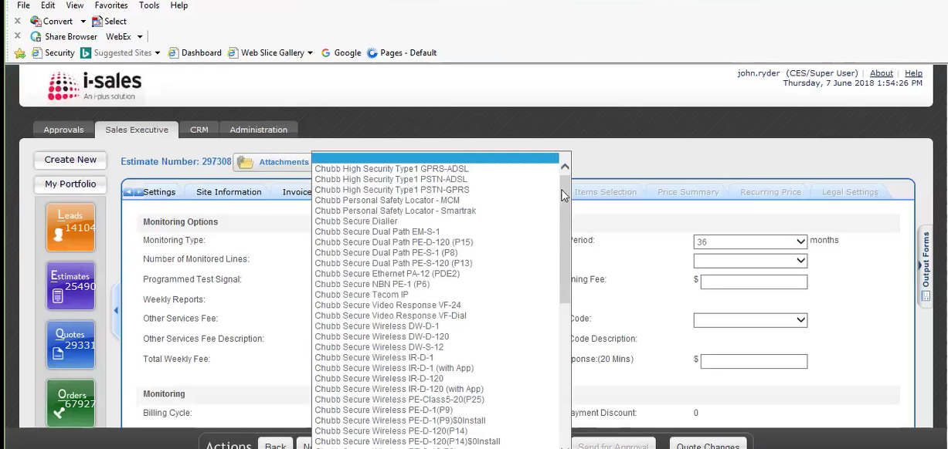

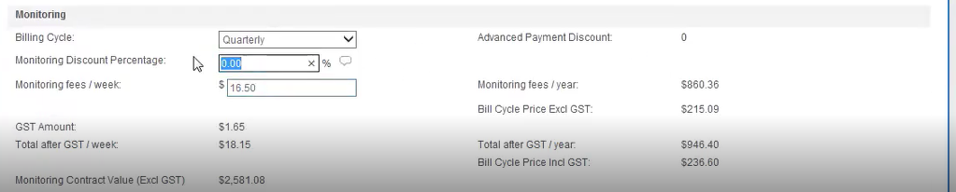

Figure 7: iSales Monitoring Options

## Item Selection

Items info from from ERP to iSales. There are around 2.5 k items for Security and 10k for Fire.

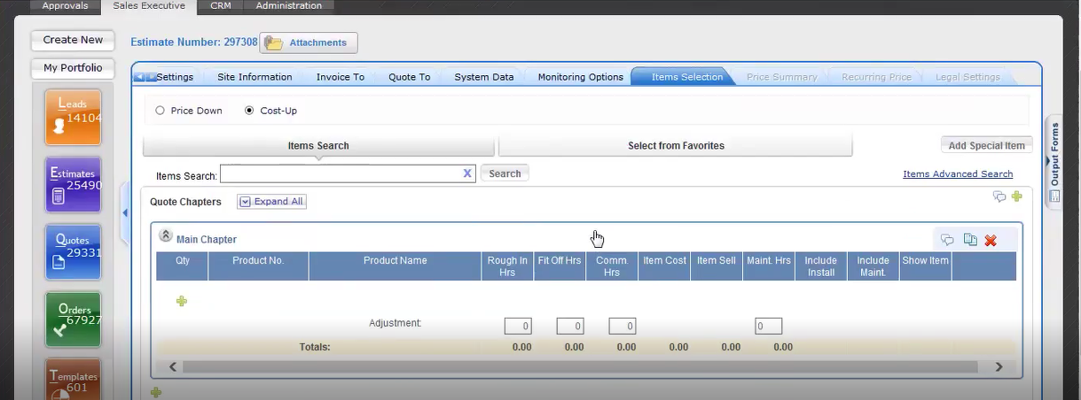

Figure 8: Item Selection

Item selection is where the salesperson will be able to build the configuration for installation and maintenance system.

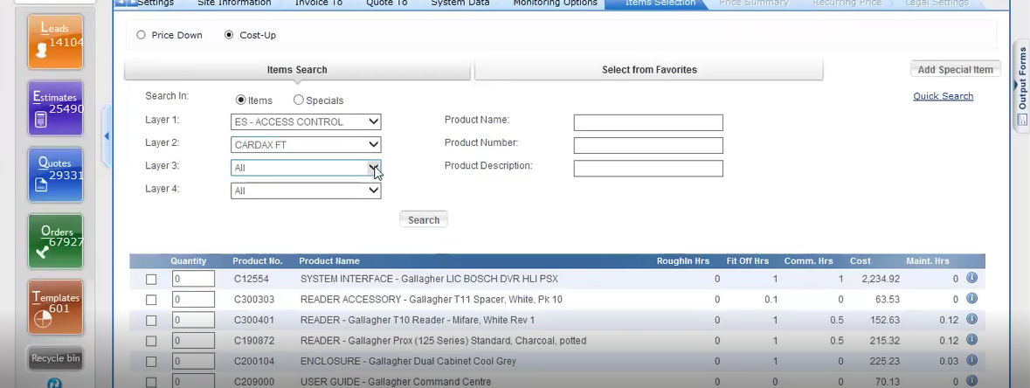

Figure 9: iSales quote Item Search

User uses item search screen to look for an item to add into quote.

They checkbox to add the item in quote and use quantity field to specify quantity and then user clicks button “Add to chapter” to add the item in quote..

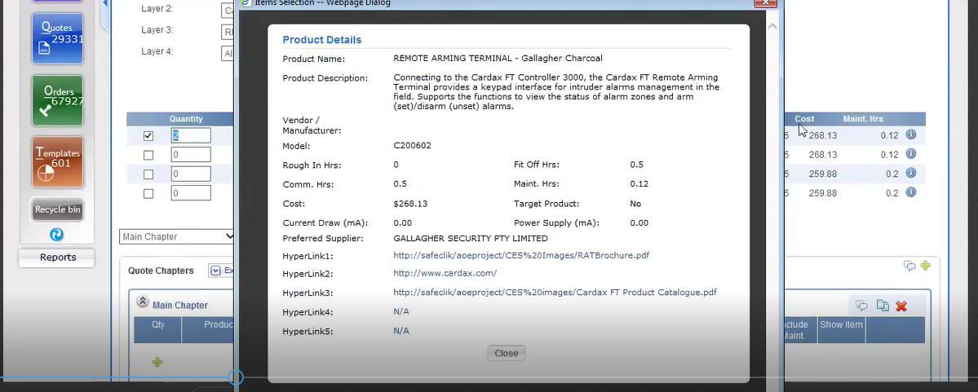

Figure 10: iSales quote Item Details

There is details button in front of each item if user wants to see more details. User can use URLs on the detailed screen to see brochure.

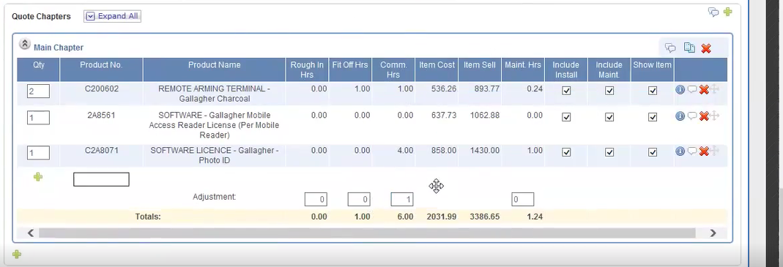

Figure 11: iSales quote Item Quantity Setting

After item is added user can edit it further for adjustments like adding or reducing hours. No discounting at item level for Security business.

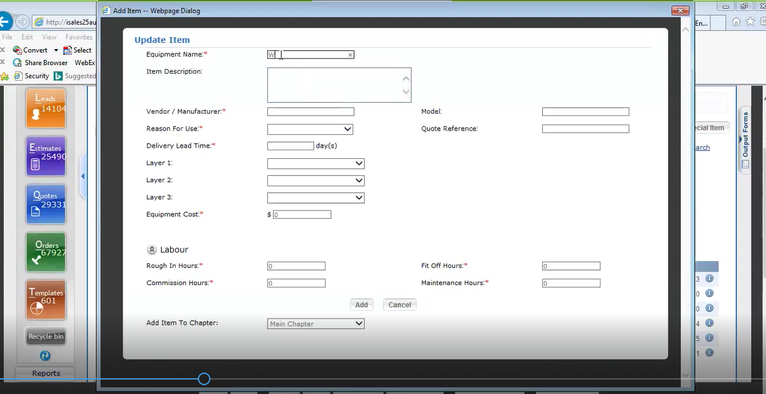

Figure 12: iSales quote Special Item

If user wants to add item that is not available in ERP then there is provision to add special item.

User can add many section called Chapters in quote like Access Control, CCTV etc. It is used to bundle items in a package.

(*Fire business does the configuration in excel spreadsheet (as iSales cannot handle complex calculations required) and attach it with quote. Fire uses chapters to refer physical locations like building1, building2 etc so that quote price is broken down per locations in site.)

Quote can have child quotes. This is used when client wants facility to choose any one quote among the many.

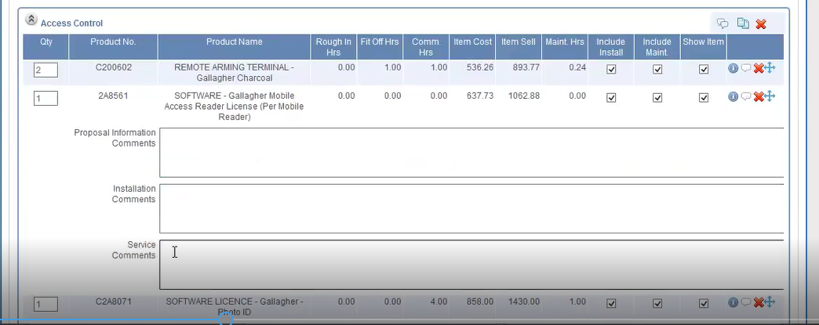

Figure 13: iSales quote Item Notes

Against each item user can enter notes which appears in final quote.

## Price Summary Screen-

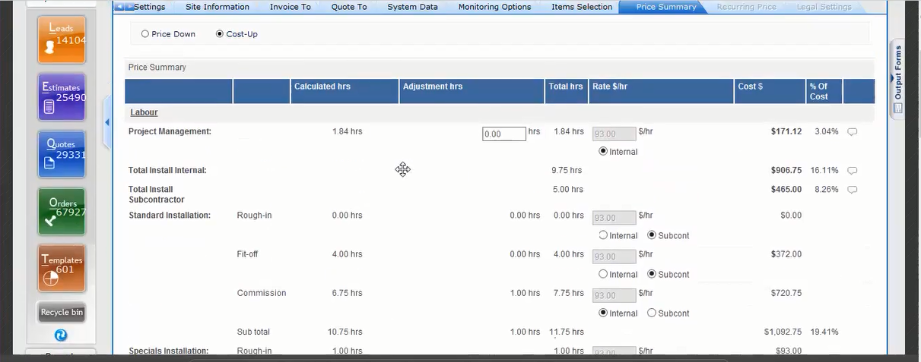

Figure 14: iSales quote Price Summary

Sum of prices selected in Item Selection screen will appear on this screen where discount can be added.

Standard margin and low $ value quotes are self approved, else it will go to approval workflow.

Whether job will go to service department (small jobs) or installation department can be set on this screen.

GST amount is displayed on this screen.

## Recurring Price

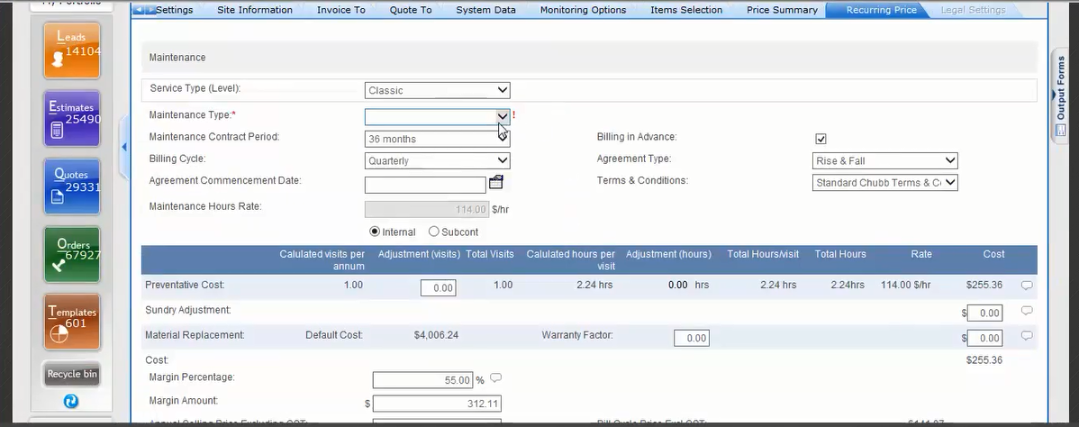

Figure 15: iSales quote Recurring Price

This tab appears if quote has maintenance part.

There are 3 Types of maintenance contracts -

* 24/7 Premium
* Business Hours Premium
* Classic

Quote is not linked to old quotes for same customer so identifying whether its service renewal is difficult.

## Legal Settings

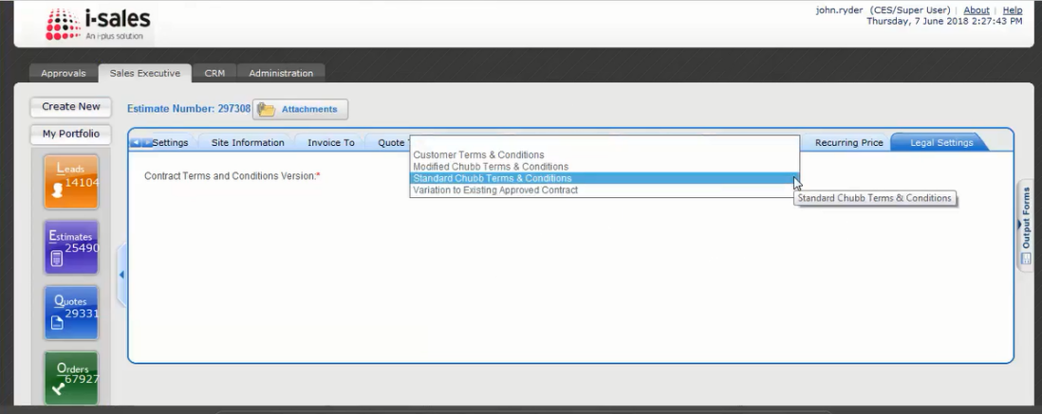

Figure 16: iSales quote Legal Settings

Option selected here triggers legal approval process.

For Standard Contract Term there are no legal approvals required.

## Approver Workflow -

If approval is triggered then approver will get screen like below

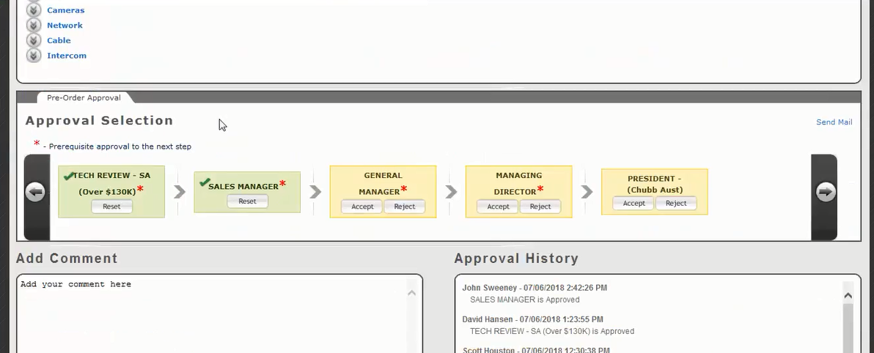

Figure 17: iSales quote Approval Workflow

Approver goes to Quote Settings screen and marks the quote as proposed.

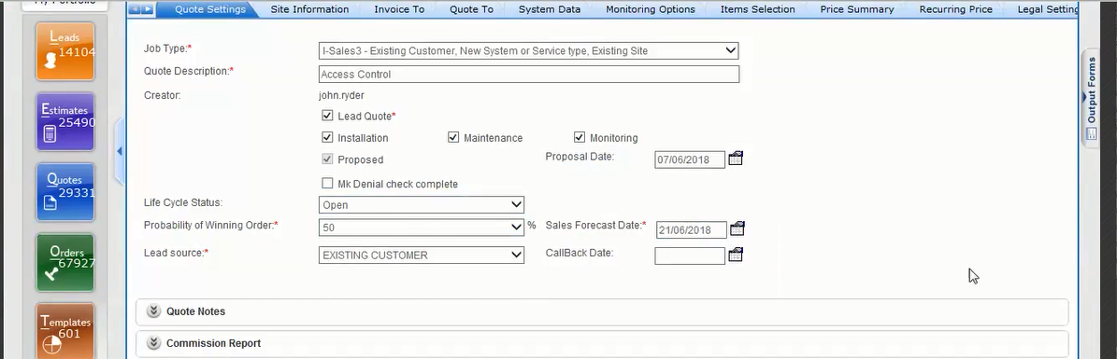

Figure 18: iSales quote Approver Action

## Output Forms

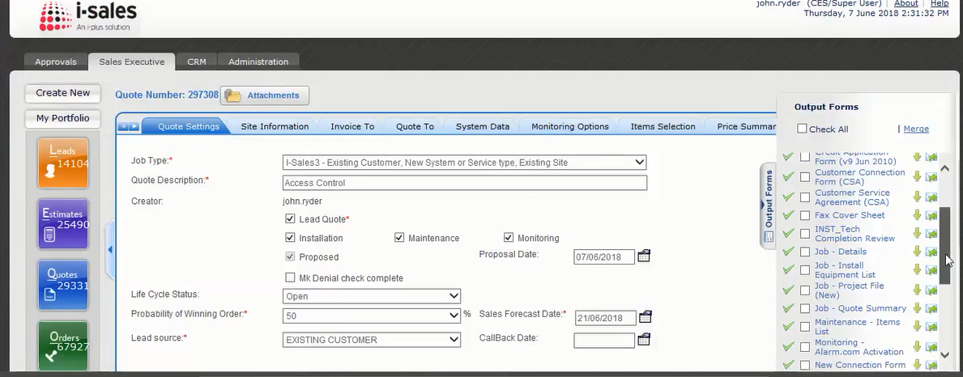

Figure 19: iSales quote Output Forms

This functionality provides reports for internal and external use.

User enters Scope of Work into output form that is in MS Word format.

(*Fire business they use another tool which generates output forms in HTML format which are difficult to edit and requires experts. The tool can also send it to customer.)

Edited output form is then attached to the quote in iSales.

Along with quote, many other documents like Drawings, Contract Document can be attached to the quote in iSales.

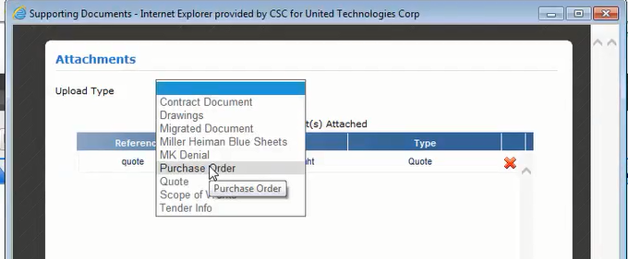

Figure 20: iSales quote Attachment

## Quote Negotiations and Quote Closing

Sales person negotiates with customer and enter logs in Notes section which manager can review.

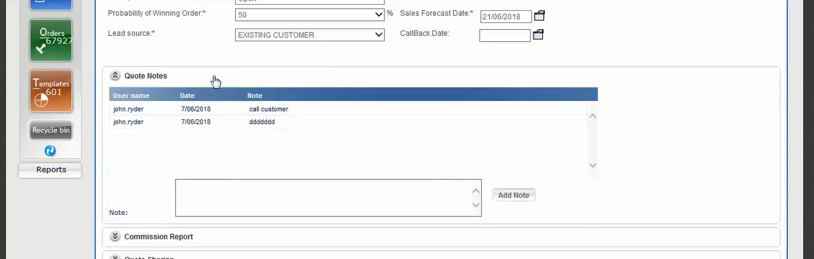

Figure 21: iSales quote Negotiations Log

After successful negotiations sales person marks the quote as Won and triggers email to administrator with iSales Quote number.

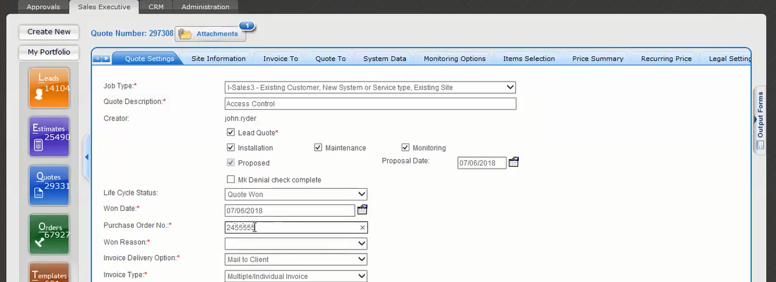

Figure 22: iSales quote Mark as Won

Administrator visits the quote and sends the quote to ERP (back end) for execution. Quote record in iSales becomes order and it cannot be edited further.

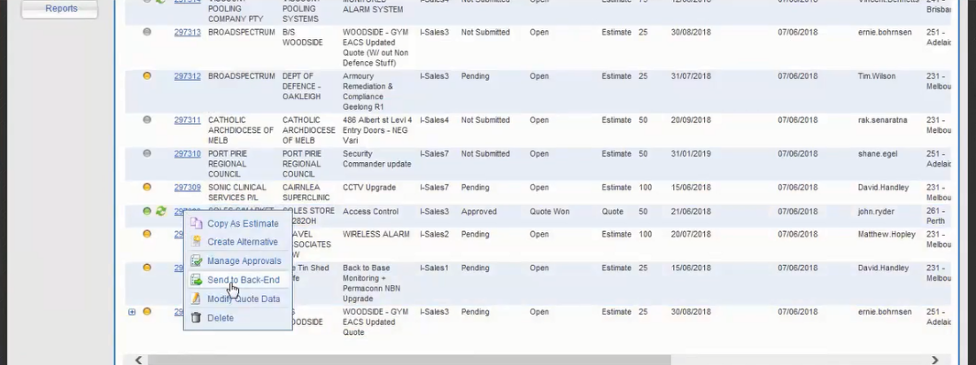

Figure 23: iSales quote Send Data to ERP